
Heat and Energy Efficient Scotland: Area-Based Scheme (Orkney)

Annual Report 2023/24

Contents
About the HEES: ABS in Orkney Page 2
Headlines and Statistics from 2023/24 Page 3
Year in numbers – trends and analysis Page 3
Communities Page 4
1
About the Heat and Energy Efficient Scotland: Area-Based Scheme in Orkney
Orkney Islands Council (OIC) was awarded funding from the Scottish Government through the Heat and Energy Efficient Scotland: Area-Based Scheme (HEES: ABS) in 2023/2024. A grant of up to £11,000 – £16,600 was made available per customer, with a higher grant award available in certain circumstances. The higher grant level is available where customers are living in extreme fuel poverty, defined as where more than 20% of the net household income is spent on energy bills to maintain an adequate standard of warmth.
Warmworks is the scheme's Managing Agent, having first been appointed by OIC in March 2020. The scheme aims to make homes warmer, more energy efficient, and more affordable to heat through the installation of energy efficiency improvements, primarily insulation.
The scheme also aims to develop the local supply chain, creating jobs and lasting benefits for local people throughout Orkney.

About Warmworks
Warmworks is committed to providing affordable warmth to homes, families and communities nationwide. We have helped tens of thousands of people to better manage their energy use and live warmer, happier, healthier lives.
We were founded in 2015 as a joint venture partnership between Energy Saving Trust, Changeworks and Everwarm.

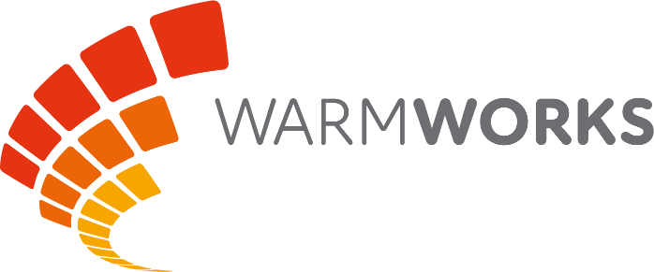

2
Headlines and Statistics
Over £1.6million in grants were claimed during 2023/24, exceeding all previous years since the scheme was first launched in 2014.
A total of 229 energy efficiency improvements were installed in 172 households across Orkney.
The improvements installed under the HEES: ABS during 2023/24 have seen the energy efficiency rating in benefitting homes, as measured by the Standard Assessment Procedure (SAP), increase by an average of 8.68 points.
Of the applications received for the scheme, 16% were in SAP Bands F or G—the least energy-efficient properties in Orkney. The energy efficiency improvements installed under the scheme this year have helped to save more than 116 tonnes of CO₂ *, equivalent to planting 5,800 trees**.
As a result of the energy efficiency improvements installed, customers who have received support from the HEES: ABS have been able to save, on average, £924 against their energy bills annually.
*Elmhurst RdSAP savings calculation tool
**Source: Anthesis Climate Neutral Group
- Installations
The HEES: ABS is delivered across Orkney and provides support to those who need it most. The map below shows where work has been carried out in the past year.
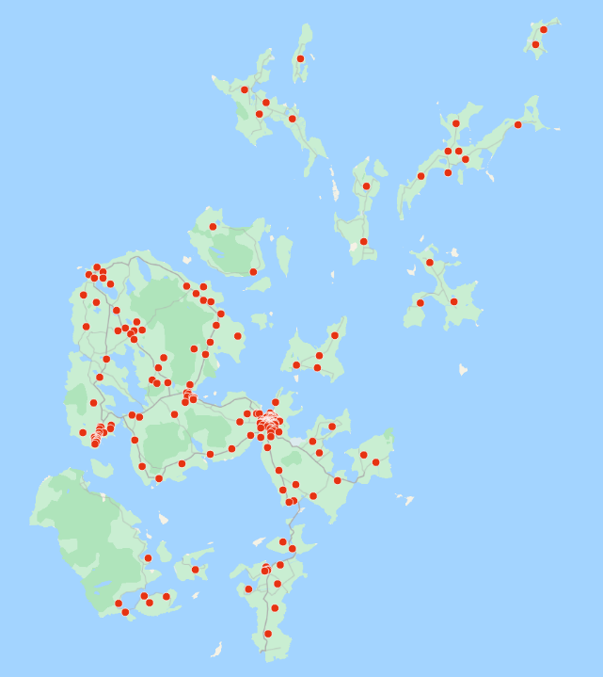

3
Range of energy efficiency improvements installed
The table below shows the total number of each type of energy efficiency improvement installed through the HEES: ABS across the 172 households supported this year:
Energy efficiency improvement installed | Number installed during 2023/24
Electric storage heaters | 64
External wall insulation | 10
Floor insulation | 13
Internal wall insulation | 27
Loft insulation top-up | 46
Loft insulation (new) | 11
Robotically applied underfloor insulation | 36
Smoke alarms | 4
Smart ventilation systems | 18
Grand Total | 229

Referral route for applications received
The table below outlines how customers heard about the HEES: ABS in Orkney over the past year:
Referral route | *Annual actual
Word of mouth | 123
Home Energy Scotland | 61
Radio | 12
Social Media | 13
Community Group referral | 58
Newspaper | 8
Other marketing projects | 23
Grand Total | 298

*Please note that the numbers given above include applications that may still be in progress and are likely to be completed during the 2024/25 scheme year.

4
Age profile of applications received
The chart below shows the age profile of the applicants who received help under the HEES: ABS during 2023/24:

Communities
In delivering the scheme on behalf of OIC, Warmworks recognises the need to ensure that as well as helping people become warmer in their homes, the scheme also provides real and lasting benefits for the local community.
During 2023/24, Warmworks worked closely with the Education Board in Orkney to increase awareness of the climate emergency and cost of living crisis. This involved building knowledge of the Curriculum for Excellence and STEM approaches to learning in schools, and then inviting children in Primary 1 and 2, in each of the Orkney primary schools, to take part in an art competition. The competition involved children designing a graphic that demonstrated what being warm at home and at school means to them.
The entries are pictured below, alongside Warmworks’ Local Engagement Manager, Michelle Koster.
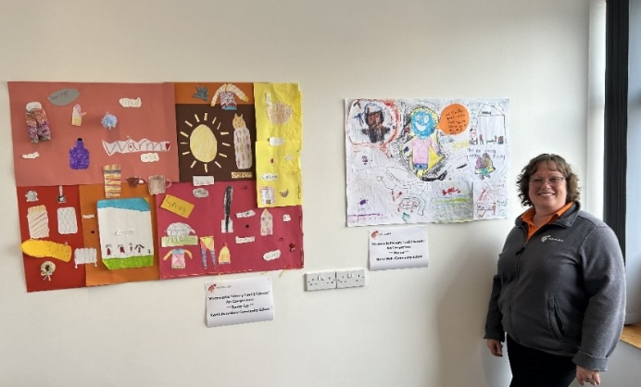
5

Our outreach opportunities have also extended to working with both Link and Wellbeing coordinators supporting NHS Orkney via local GP surgeries across the Islands as well as a programme of attendance at The Balfour hospital to engage with staff, patients and visitors to widen awareness of the scheme and be available to those needing assistance with heating or insulation. This has helped us to target members of our community where health may be affected by living in a home whilst struggling to maintain an adequate standard of warmth.

6

